Module -1 Overview Of IT Industry
—-------------------------------------------------------------------------------------------------

Q.1 Explain in your own words what a program is and how it functions.
Ans. Program instruction for a computer to execute a task. If contains write by programing language machine will be read and execute a program.

Q.2 What are the key steps involved in the programming process?
Ans. Programing Process involves 6 main steps.
1)Identifying the problem and requirements
2)Designing a solution using techniques
3)Writing the program by choosing language and following its syntax
4)Testing For Error
5)Documenting the program
6)Maintaining the program with user guides and code comments.

Q.3 What are the main differences between high-level and low-level programming language?
Ans. High-level languages prioritize ease of use and abstraction, enabling rapid development and code readability, while low-level languages provide precise control over hardware and memory, making them crucial for tasks demanding maximum performance and direct hardware control.

Q.5 Describe the role of the client and server in web communication.
Ans A client is a program that runs the local machine requesting service from the server.A client program is a finite program means that the service started by the user and terminates when the service is completed.A server is a program that run on the remote machine providing services to the clients.When the client request for a service,then the server opens the door for the incoming requests,but it never initiates the service.

Q.6 Explain client server communication.
Ans. Clients and server exchange messages in a request-response messaging pattern.The client sends a request, and the server returns a response.This exchange of messages in an example of inter-process communication.

Q.7 Research different types of internet connections.
Ans 1) Broadband -
Pros : Faster speed , Reliability , Security , Accessiblity
Cons : Cost , Installation , Availability
2) Fiber -
Pros : Future Proof Technology , High speed , Reliability
Cons : Cost , Availability , Installation Challenges
3) Satellite -
Pros : Global Coverage , Low infrastructure cost , 24/7 Availabillty
Cons : High Initial cost , Maintenance and repair costs

Q.8 How does broadband differ from fiber-optic internet?
Ans Broadband is a general term for high speed internet. Fiber optic internet is a specific type of broadband that uses thin glass or plastic fibers to transmit data , offering faster speed and lower latency.

Q.9 What are the differences between HTTP and HTTPS protocols?
Ans HTTP is not secure web-site , When HTTPS secure web-site.HTTPS is more secure than HTTP.

Q.10 Identify and explain three common application security vulnerabilities.
Ans Front Design Webpage than input user data and chek the given data is right or wrong and data will be store in data base page.

Q.11 What is the role of encryption in securing applications?
Ans Encryption is used to protect data from being stolen , changed or compromised and works by scrambling data into a secret code that can only be unlocked with a unique digital key.

Q.12 Identify and classify 5 applications you use daily as either system software or application software.
Ans Calculator , Notepad , Wordpad , Microsoft Excel , Music Player

Q.13 What is the difference between system software and application software?
Ans System software provide a platform for other software to run , While application software performs specific tasks for the user , So both are the necessary in your computer to work properly.

Q.14 Design a basic three-tier software architecture diagram for a web application.
Ans 1)Presentation Layer 2)Application Layer 3)Data Layer

Q.15 What is the significance of modularity in software architecture?
Ans .Yes, modularity can indeed extend the lifespan of a software product. By organizing code into modular components, you create a flexible structure that can adapt to changing requirements. This makes it easier to update or replace parts of the system, ensuring that your software remains relevant and functional over time.

Q.16 Why are layers important in software architecture?
Ans Layered architecture is a fundamental software design pattern that provides a clear separation of concerns and promotes modularity and flexibility in software systems. It allows for the development of robust, scalable, and maintainable applications that can adapt to changing business requirements.

Q.17 Explain the importance of a development environment in software production.
Ans One of the most important uses of a development environment is that it allows developers to ensure various functions of the application/program work as intended before it is released to users. It allows developers to make any change to the program/code in a controlled setting without impacting users.

Q.18 What is the difference between source code and machine code?
Ans .Source code is not directly understandable by machine. Object code is machine understandable and executable. It is written in a high-level language like C, C++, Java, Python, etc., or assembly language. It is written in machine language through compiler or assembler or other translator.

Q.19 Why is version control important in software development?
Ans .Version control software facilitates coordination, sharing, and collaboration across the entire software development team. It enables teams to work in distributed and asynchronous environments, manage changes and versions of code and artifacts, and resolve merge conflicts and related anomalies.

Q.20 What are the benefits of using Github for students?
Ans The GitHub Student Developer Pack is a comprehensive set of tools and services provided by GitHub , specifically designed for students. It includes access to premium tools and resources from GitHub and its partners, helping students learn, build projects, and grow their skills in software development.

Q.21 Create a list of software you use regularly and classify them into the following categories: system, application, and utility software.
Ans Microsoft Excel - System Software , Microsoft Word - System Software , Calculator - System Software , Google Chrome - Application Software , Git-Hub - Application Software , VS Code - application Software

Q.22 What are the differences between open-source and proprietary software?
Ans .Open source refers to technology and software that is available for anyone to use or edit. Proprietary is copyrighted technology that must be used with a license.

Q.23 How does GIT improve collaboration in a software development team?
Ans Git is a distributed version control system that empowers developers to work together effectively. The tool enables collaborative development by allowing developers to work on the same codebase simultaneously, track changes, and merge their contributions.

Q.24 Write a report on the various types of application software and how they improve productivity.
Ans 1)Productivity Software: Tools like Microsoft Office and Google Workspace help users create and manage documents, spreadsheets, and presentations, saving time and reducing errors.2)Multimedia Software: Applications like Adobe Photoshop and VLC Media Player allow users to create and edit multimedia content, enabling them to produce high-quality content for personal or professional use.3)Web Browsers: Browsers like Chrome and Firefox facilitate easy access to websites and online platforms, allowing users to stay updated with information and resources. 4)Communication Software: Tools like Zoom and Slack enable teams to communicate effectively, facilitating collaboration and teamwork.

Q.25 What is the role of application software in businesses?
Ans Application software helps businesses organize their data successfully, which is essential for corporate success. Businesses may store, arrange, and evaluate their data using tools like databases, spreadsheets, and analytics software. This enables them to make well-informed decisions and develop strategic plans.

Q.26 What are the main stages of the software development process?
Ans Phase 1: Planning. ...Phase 2: Requirements Analysis. ...Phase 3: Design. ...Phase 4: Coding. ...Phase 5: Testing. ...Phase 6: Deployment. ...Phase 7: Maintenance. …

Q.27 Why is the requirement analysis phase critical in software development?
Ans Requirement analysis is a crucial stage in software development where the needs and expectations of stakeholders are identified and documented. This phase ensures that the development team clearly understands what the software should achieve and the specific conditions it must meet.

Q.28 What is the role of software analysis in the development process?
Ans It helps ensure that the software system meets the requirements of the stakeholders. By understanding the requirements and analyzing them thoroughly, software analysts and designers can create a system that meets the needs of the users. It helps identify and mitigate risks.

Q.29 What are the key elements of system design?
Ans 1) Requirements & Constraints 2) High-Level architecture 3) Data Design 4) Scalability Strategy 5) Reliability & Fault Tolerance 6) Performance Optimization 7) Security 8) Deployment & Infrastructure 9) Observability & Operations 10) Trade-offs & Evolution.

Q.30 Why is software testing important?
Ans .In conclusion, software testing is essential for maintaining a high standard of quality, reliability, and security in any application. Through testing, developers can detect issues early, improve functionality, and ensure that the software meets both user expectations and industry standards.

Q.31 What types of software maintenance are there?
Ans 4 type of software maintenance are there. 1) Corrective Maintenance 2) Preventive Maintenance 3) Perfective Maintenance 4) Adaptive Maintenance

Q.32 What are the key differences between web and desktop applications?
Ans Web and desktop applications have different strengths and weaknesses. Web apps are accessible from anywhere with an internet connection, while desktop apps must be installed on each user's device. Desktop apps perform better, work offline, and keep data more secure.

Q.33 What are the advantages of using web applications over desktop applications?
Ans Web apps are accessible from anywhere with an internet connection, while desktop apps must be installed on each user's device. Desktop apps perform better, work offline, and keep data more secure. Yet, web apps allow real-time collaboration and avoid version update issues.

Q.34 What role does UI/UX design play in application development?
Ans .Good UI design makes products visually appealing, while good UX design ensures they are easy to use and meet user needs. Investing in quality UI/UX design can lead to higher user satisfaction, increased engagement, and overall success for your digital products.

Q.35 What are the differences between native and hybrid mobile apps?
Ans .In a native app, your developers have to rewrite and redesign all the app functionality in the native development language. A hybrid app lets you write the app functionality in a single codebase. You can then wrap your code in a lightweight native app shell or container.

Q.36 What is the significance of DFDs in system analysis?
Ans .The main purpose of DFDs is to support system analysis and improve business processes. These diagrams simplify complex systems by showing the data flow between components, making system analysis and decision-making easier.

Q.37 What are the pros and cons of desktop applications compared to web applications?
Ans .Web applications offer unparalleled convenience and accessibility, making them ideal for applications that demand real-time collaboration and global accessibility. On the other hand, desktop apps are more suitable for tasks that require robust performance, offline access, and enhanced security.

Q.38 : How do flowcharts help in programming and system design?
Ans .As a visual representation of data flow, flowcharts are useful in writing a program or algorithm and explaining it to others or collaborating with them on it. You can use an algorithm flowchart to spell out the logic behind a program before ever starting to code the automated process.

Q.39 Create a flowchart representing the Software Development Life Cycle (SDLC).
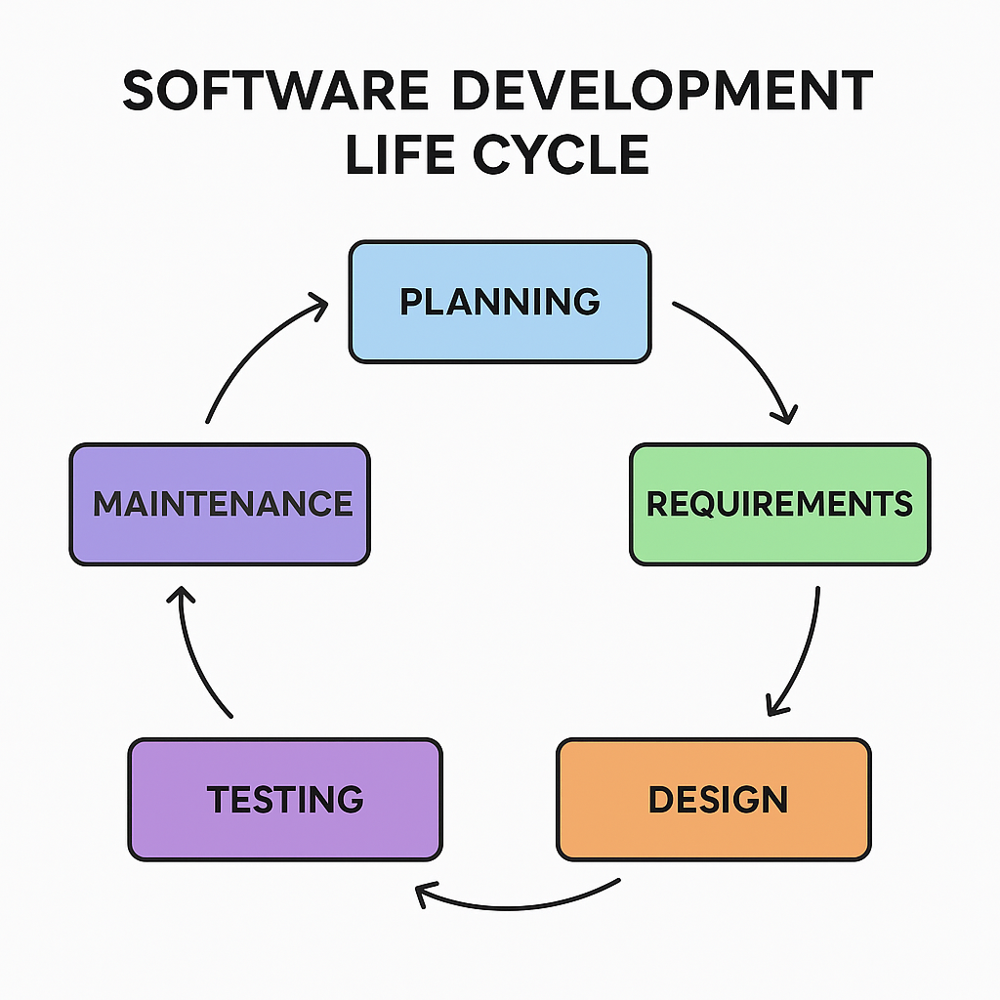
Q.40 Design a basic system architecture for a food delivery app.
Ans 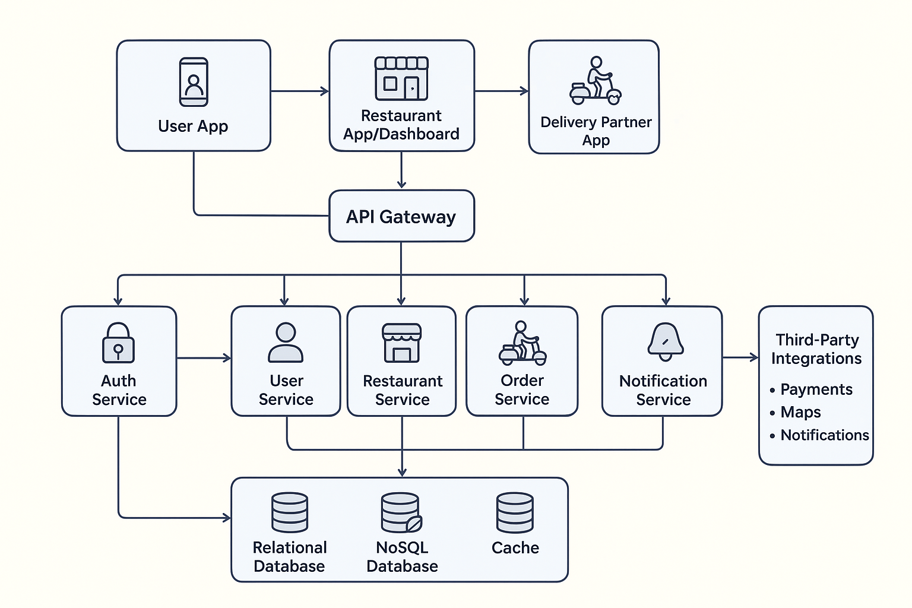

Q.41 Create a DFD for a hospital management system.
Ans
[Doctor]
|
| Diagnosis, Prescription
v
[Patient] --> ( Hospital Management System ) --> [Pharmacy]
| | | |
| | | | Medicine Details
| | v v
| | [Laboratory] [Insurance Company]
| | Test Results Claim Approval
| |
| v
| Bills, Reports
v
Appointment Request

